**Decision Modeling Mini Project**

Project Report

**TITLE**

**Speed Racer – A game made using Python**

Team Members:

Sharvaj Patil (4808540)

Dinesh Saliyar (4820242)

Sakshi Dhadwad (4505044)

Gaurav Patil (4671956)

Alex Fernandes (4810930)

# Introduction Aim

# The primary aim of the Speed Racer project is to design and develop an engaging, interactive 2D racing game using the Python programming language and the Pygame library.

# Problem Statement

# In the realm of interactive entertainment and software development, creating engaging and educational projects is a significant challenge. One area that offers a comprehensive learning experience is game development, which encompasses various aspects of programming, multimedia integration, and user interaction design. The goal is to develop a simple yet entertaining 2D racing game using Python and the Pygame library

# Introduction

Speed Racer is an engaging, fast-paced racing game developed using Python and the Pygame library. The objective is to navigate the car through a busy road while avoiding obstacles and collecting fuel to maintain the journey. The game keeps track of the distance traveled and the player's high score.

# Scope

The scope of the Speed Racer project encompasses the design, development, testing, and documentation of a 2D racing game using Python and the Pygame library. The project aims to deliver a fully functional, engaging game that serves as both an educational tool and an entertainment product.

# Objectives

1. Navigate the Car
2. Avoid Obstacles
3. Collect Fuel
4. Maximize Distance
5. Achieve High Scores
6. Maintain Fuel Levels
7. Experience Progression
8. Provide Feedback and Enjoyment

# Motivation

The motivation behind the Speed Racer project stems from a combination of educational, creative, and entertainment-driven factors. Developing a 2D racing game using Python and Pygame offers an excellent opportunity to explore various aspects of game development, enhance programming skills, and create a fun and interactive application.

# Literature Review References

* Pygame Documentation <https://www.pygame.org/docs/>
* Tutorials on Pygame Game Development [https://www.youtube.com/watch?v=XON1IA8MxQw&list=PLz7mmheD](https://www.youtube.com/watch?v=XON1IA8MxQw&list=PLz7mmheDeooW795HsNzkLS6TFQSa4Idtw) [eooW795HsNzkLS6TFQSa4Idtw](https://www.youtube.com/watch?v=XON1IA8MxQw&list=PLz7mmheDeooW795HsNzkLS6TFQSa4Idtw)

# Methodology

## Pygame Library

Pygame is a set of Python modules designed for writing video games. It includes computer graphics and sound libraries.

## Game Components

**Car:** The player-controlled vehicle that navigates the road.

**Road:** The track or path on which the car travels.

**Obstacles:** Various objects or entities that the player must avoid, such as other cars or barriers.

**Fuel Pickups:** Items that the player collects to replenish the car's fuel and continue driving.

**User Interface (UI):** Visual elements displayed on the screen to provide information to the player, including score, fuel level, and high score.

**Graphics:** Visual assets such as car sprites, road backgrounds, obstacles, and fuel pickups.

**Audio:** Sound effects for actions like collecting fuel, crashing, and background music to enhance the gaming experience.

**Game Logic:** Code that governs the rules and mechanics of the game, including collision detection, scoring, and fuel management.

**Game States**: Different states of the game, such as running, paused, and game over, are managed by the game loop.

**Control System:** Keyboard inputs used by the player to control the car's movement, typically using arrow keys or other designated keys.

**High Score System**: Mechanism to track and display the highest score achieved by the player across multiple game sessions.

**Performance Optimization:** Techniques employed to ensure the game runs smoothly at a consistent frame rate, even on different hardware configurations

# Implementation

**Code**

The game is implemented in Python using the Pygame library. Below is a simplified version of the main game loop:

# game.py

# import pygame

# import time

# import random

# import os

# pygame.init()

# pygame.mixer.init()

# gameWindow = pygame.display.set_mode((1200,700))

# pygame.display.set_caption("Speed Racer")

# clock = pygame.time.Clock()

# fps = 60

# font1 = pygame.font.SysFont("Franklin Gothic Demi Cond",50)

# car = pygame.image.load("data/images/Car.png")

# car = pygame.transform.scale(car,(150,150)).convert_alpha()

# road = pygame.image.load("data/images/Road.png")

# road = pygame.transform.scale(road,(400,700)).convert_alpha()

# sand = pygame.image.load("data/images/Sand.jpg")

# sand = pygame.transform.scale(sand,(150,700)).convert_alpha()

# leftDisp = pygame.image.load("data/images/LeftDisplay.png")

# leftDisp = pygame.transform.scale(leftDisp,(250,700)).convert_alpha()

# rightDisp = pygame.image.load("data/images/RightDisplay.png")

# rightDisp = pygame.transform.scale(rightDisp,(250,700)).convert_alpha()

# tree = pygame.image.load("data/images/Tree.png")

# tree = pygame.transform.scale(tree,(185,168)).convert_alpha()

# treeLXY = [[290,0],[290,152.5],[290,305],[290,457.5],[290,610]]

# treeRXY = [[760,0],[760,152.5],[760,305],[760,457.5],[760,610]]

# strip = pygame.image.load("data/images/Strip.png")

# strip = pygame.transform.scale(strip,(25,90)).convert_alpha()

# stripXY = [[593,0],[593,152.5],[593,305],[593,457.5],[593,610]]

# explosion = pygame.image.load("data/images/Explosion.png")

# explosion = pygame.transform.scale(explosion,(290,164)).convert_alpha()

# fuel = pygame.image.load("data/images/Fuel.png")

# fuel = pygame.transform.scale(fuel,(98,104)).convert_alpha()

# comingCars,goingCars = [],[]

# speedCC = [13,14,15,14,14,15,13,14,15]

# speedGC = [8,6,7,5,8,7,8,6,8]

# for i in range(1,10):

# CCi = pygame.image.load("data/images/Coming Cars/"+"CC"+str(i)+".png")

# CCi = pygame.transform.scale(CCi, (75, 158)).convert_alpha()

# comingCars.append([CCi,speedCC[i-1]])

# GCi = pygame.image.load("data/images/Going Cars/"+"GC"+str(i)+".png").convert_alpha()

# GCi = pygame.transform.scale(GCi,(75,158)).convert_alpha()

# goingCars.append([GCi,speedGC[i-1]])

# def distance(carX,obstX,carY,obstY,isFuel = False):

# if not isFuel:

# carX += 75 # 75,75,37,79,55,130

# carY += 75

# obstX += 37

# obstY += 79

# return abs(carX - obstX) < 55 and abs(carY - obstY) < 130

# else:

# carX += 75

# carY += 75

# obstX += 98

# obstY += 104

# return abs(carX - obstX) < 70 and abs(carY - obstY) < 80

# def textOnScreen(text,color,x,y,font):

# screenText = font.render(text,True,color)

# gameWindow.blit(screenText,[x,y])

# def slowDown(carX,carY,dist,highscore):

# stripXY_ = [[593, 0], [593, 152.5], [593, 305], [593, 457.5], [593, 610]]

# exitScreen = False

# stripSpeed = 2

# start = time.time()

# while not exitScreen:

# if time.time() - start > 3:

# stripSpeed = 1

# if time.time() - start > 6:

# exitScreen = True

# for event in pygame.event.get():

# if event.type == pygame.QUIT:

# exitScreen = True

# gameWindow.fill((0,0,0))

# gameWindow.blit(leftDisp, (0, 0))

# textOnScreen("DISTANCE", (255, 255, 0), 27, 388, font1)

# textOnScreen(str(dist) + " Kms", (255, 0, 0), 56, 480, font1)

# textOnScreen("FUEL", (255, 255, 0), 73, 90, font1)

# textOnScreen(str(0.00) + ' %', (255, 0, 0), 75, 184, font1)

# gameWindow.blit(rightDisp, (950, 0))

# textOnScreen("HIGHSCORE", (255, 255, 0), 958, 236, font1)

# if(highscore < 10):

# disp = str(0) + str(highscore)

# else:

# disp = str(highscore)

# textOnScreen(disp + " Kms", (255, 0, 0), 1005, 342, font1)

# gameWindow.blit(road, (400, 0))

# gameWindow.blit(sand,(250,0))

# gameWindow.blit(sand,(800,0))

# for i in range(len(stripXY_)):

# stripXY_[i][1] += stripSpeed

# if stripXY_[i][1] > 700:

# stripXY_[i] = [593, -60]

# for i in range(len(treeLXY)):

# treeLXY[i][1] += stripSpeed

# if treeLXY[i][1] > 700:

# treeLXY[i] = [290,-60]

# for i in range(len(treeRXY)):

# treeRXY[i][1] += stripSpeed

# if treeRXY[i][1] > 700:

# treeRXY[i] = [760,-60]

# for X,Y in stripXY_:

# gameWindow.blit(strip,(X,Y))

# for treeX,treeY in treeLXY:

# gameWindow.blit(tree,(treeX,treeY))

# for treeX,treeY in treeRXY:

# gameWindow.blit(tree,(treeX,treeY))

# gameWindow.blit(car,(carX,carY))

# pygame.display.update()

# def gameLoop():

# pygame.mixer.music.load("data/audios/lmn.mp3")

# pygame.mixer.music.play()

# time.sleep(1)

# carX,carY = 625,540

# drift = 4

# carSpeedX = 0

# obstacleXY = [[460,-10],[710,-300]]

# c1,c2 = random.randint(0,8),random.randint(0,8)

# if(c1 == c2):

# c1 = random.randint(0,8)

# obstacleSpeed = [comingCars[c1][1],goingCars[c2][1]]

# obstacles = [comingCars[c1][0],goingCars[c2][0]]

# stripSpeed = 9

# exitGame = False

# gameOver = False

# explode = False

# fuelCount = 50

# fuelX,fuelY = random.randint(420,620),-1000

# fuelSpeed = 8

# dist = 0

# with open("data/Highscore.txt","r") as f:

# highscore = int(f.read())

# slow = False

# plotFuel = True

# start1 = time.time()

# start = [start1,start1]

# start2 = start1

# start3 = start1

# start4 = start1

# arrival = [2,3.5]

# while not exitGame:

# if gameOver:

# if slow:

# slowDown(carX,carY,dist,highscore)

# time.sleep(2)

# pygame.mixer.music.stop()

# pygame.mixer.music.load("data/audios/rtn.mp3")

# pygame.mixer.music.play()

# exitScreen = False

# go = pygame.image.load("data/images/GameOver.png")

# go = pygame.transform.scale(go,(1239,752)).convert_alpha()

# with open("data/Highscore.txt","w") as f:

# f.write(str(highscore))

# while not exitScreen:

# for event in pygame.event.get():

# if event.type == pygame.QUIT:

# exitScreen = True

# elif event.type == pygame.KEYDOWN:

# if event.key == pygame.K_RETURN:

# pygame.mixer.music.stop()

# homeScreen()

# gameWindow.fill((0,0,0))

# gameWindow.blit(go,(0,0))

# if(dist < 10):

# disp = str(0) + str(dist)

# else:

# disp = str(dist)

# textOnScreen(disp,(255,0,0),540,429,font1)

# pygame.display.update()

# clock.tick(fps)

# pygame.quit()

# quit()

# else:

# for event in pygame.event.get():

# if event.type == pygame.QUIT:

# exitGame = True

# elif event.type == pygame.KEYDOWN:

# if event.key == pygame.K_RIGHT:

# carSpeedX = drift

# elif event.key == pygame.K_LEFT:

# carSpeedX = -drift

# elif event.key == pygame.K_a:

# obstacleXY[0][0] -= 20

# elif event.key == pygame.K_d:

# obstacleXY[1][0] += 20

# carX += carSpeedX

# fuelY += fuelSpeed

# if time.time() - start4 >= 2:

# dist += 1

# if dist > highscore:

# highscore = dist

# start4 = time.time()

# if time.time() - start2 >= 3:

# fuelCount -= 5

# start2 = time.time()

# if distance(carX,fuelX,carY,fuelY,True) and plotFuel:

# plotFuel = False

# fuelCount += 20

# for i in range(len(obstacleXY)):

# obstacleXY[i][1] += obstacleSpeed[i]

# fuelper = fuelCount/50

# if fuelper >= 1:

# fuelper = 1

# gameWindow.fill((0,0,0))

# gameWindow.blit(leftDisp,(0,0))

# textOnScreen("DISTANCE", (255, 255, 0),27,388,font1)

# if(dist < 10):

# disp = str(0) + str(dist)

# else:

# disp = str(dist)

# textOnScreen(disp + " Kms",(255,0,0),56,480,font1)

# textOnScreen("FUEL",(255,255,0),73,90,font1)

# textOnScreen(str(fuelper*100) + ' %',(255,0,0),60,184,font1)

# gameWindow.blit(rightDisp, (950, 0))

# textOnScreen("HIGHSCORE",(255,255,0),958,236,font1)

# if(highscore < 10):

# disp = str(0) + str(highscore)

# else:

# disp = str(highscore)

# textOnScreen(disp + " Kms",(255,0,0),1005,342,font1)

# gameWindow.blit(road,(400,0))

# gameWindow.blit(sand, (250, 0))

# gameWindow.blit(sand, (800, 0))

# if fuelCount == 0:

# gameOver = True

# slow = True

# if carX > 720 or carX < 330:

# pygame.mixer.music.load("data/audios/Crash.mp3")

# pygame.mixer.music.play()

# gameOver = True

# explode = True

# for i in range(len(obstacleXY)):

# if distance(carX,obstacleXY[i][0],carY,obstacleXY[i][1]):

# pygame.mixer.music.load("data/audios/Crash.mp3")

# pygame.mixer.music.play()

# gameOver = True

# explode = True

# break

# for i in range(len(stripXY)):

# stripXY[i][1] += stripSpeed

# if stripXY[i][1] > 700:

# stripXY[i] = [593,-60]

# for i in range(len(treeLXY)):

# treeLXY[i][1] += stripSpeed

# if treeLXY[i][1] > 700:

# treeLXY[i] = [290, -60]

# for i in range(len(treeRXY)):

# treeRXY[i][1] += stripSpeed

# if treeRXY[i][1] > 700:

# treeRXY[i] = [760, -60]

# for stripX,stripY in stripXY:

# gameWindow.blit(strip,(stripX,stripY))

# if fuelY < 750:

# if plotFuel:

# gameWindow.blit(fuel,(fuelX,fuelY))

# gameWindow.blit(car,(carX,carY))

# for i in range(len(obstacleXY)):

# if obstacleXY[i][1] < 750:

# gameWindow.blit(obstacles[i],(obstacleXY[i][0], obstacleXY[i][1]))

# for treeX, treeY in treeLXY:

# gameWindow.blit(tree, (treeX, treeY))

# for treeX, treeY in treeRXY:

# gameWindow.blit(tree, (treeX, treeY))

# if time.time() - start[0] >= arrival[0]:

# x = random.randint(430,530)

# x+=3

# obstacleXY[0] = [x,-10]

# c1 = random.randint(0,8)

# obstacles[0] = comingCars[c1][0]

# obstacleSpeed[0] = comingCars[c1][1]

# start[0] = time.time()

# if time.time() - start[1] >= arrival[1]:

# x = random.randint(620,710)

# x-=3

# obstacleXY[1] = [x,-10]

# c2 = random.randint(0,8)

# obstacles[1] = goingCars[c2][0]

# obstacleSpeed[1] = goingCars[c2][1]

# start[1] = time.time()

# if time.time() - start3 >= 15:

# fuelX,fuelY = random.randint(420,710),-500

# plotFuel = True

# start3 = time.time()

# if explode:

# gameWindow.blit(explosion,(carX - 63,carY))

# pygame.display.update()

# clock.tick(fps)

# pygame.quit()

# quit()

# def homeScreen():

# pygame.mixer.music.load("data/audios/rtn.mp3")

# pygame.mixer.music.play()

# if not os.path.exists("data/Highscore.txt"):

# with open("data/Highscore.txt","w") as f:

# f.write("0")

# highscore = 0

# else:

# with open("data/Highscore.txt","r") as f:

# highscore = int(f.read())

# background = pygame.image.load("data/images/Background.png")

# background = pygame.transform.scale(background,(1213,760)).convert_alpha()

# exitScreen = False

# while not exitScreen:

# for event in pygame.event.get():

# if event.type == pygame.QUIT:

# exitScreen = True

# elif event.type == pygame.KEYDOWN:

# if event.key == pygame.K_RETURN:

# pygame.mixer.music.stop()

# gameLoop()

# gameWindow.blit(background,(-6,-32))

# if(highscore < 10):

# disp = str(0) + str(highscore)

# else:

# disp = str(highscore)

# textOnScreen(disp,(255,0,0),980,9,font1)

# pygame.display.update()

# clock.tick(fps)

# pygame.quit()

# quit()

# homeScreen()

# Game Architecture

The game architecture comprises player-controlled car navigation on a road filled with obstacles and fuel pickups, with visual and auditory feedback managed through Pygame libraries and user input controlled via keyboard events.

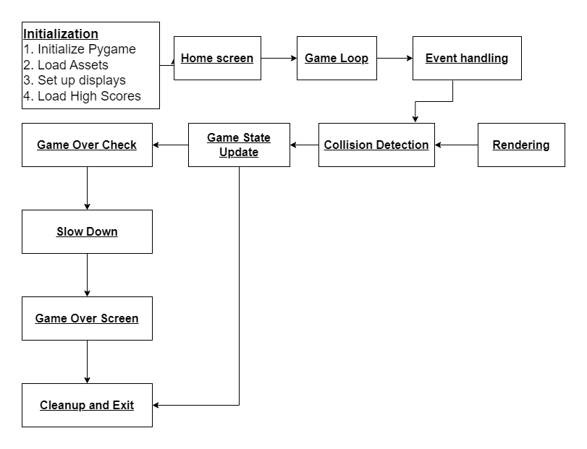

# Results

**Output Screenshot**

The game successfully recreates the core mechanics of Car. The Car moves smoothly as intended and other assets like trees, coming cars, going cars, fuel and other surroundings are correctly and timely rendered. The music behind the game also plays successfully.

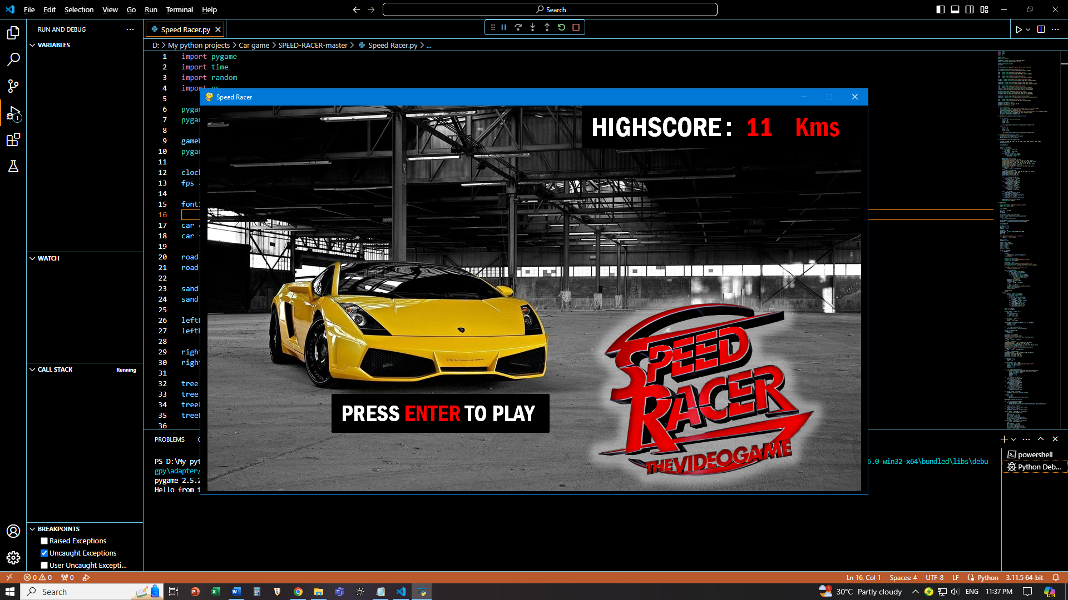

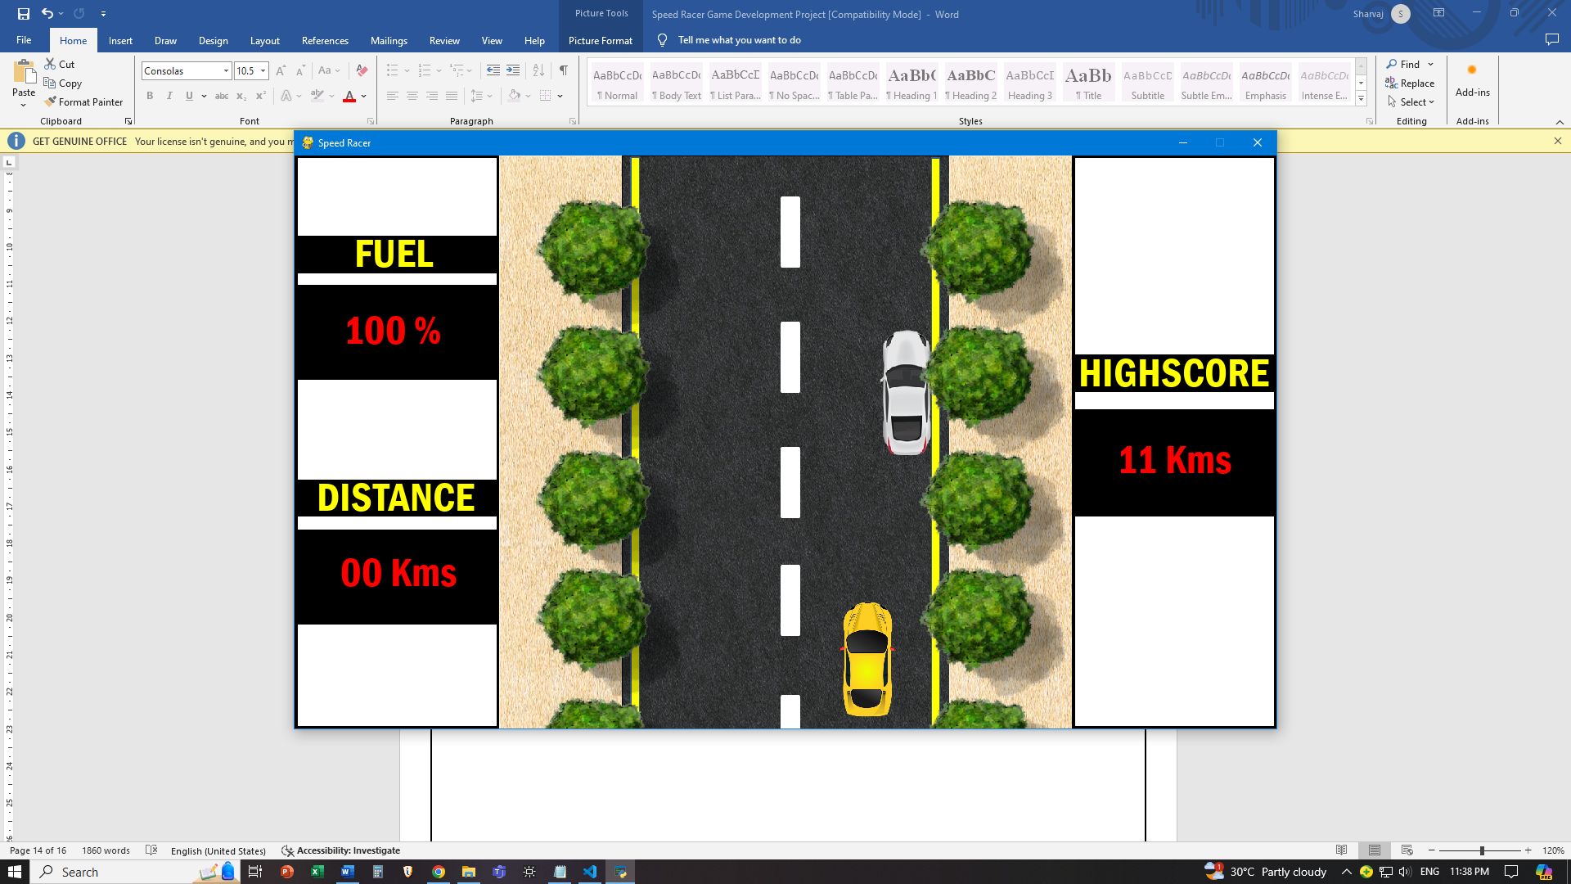

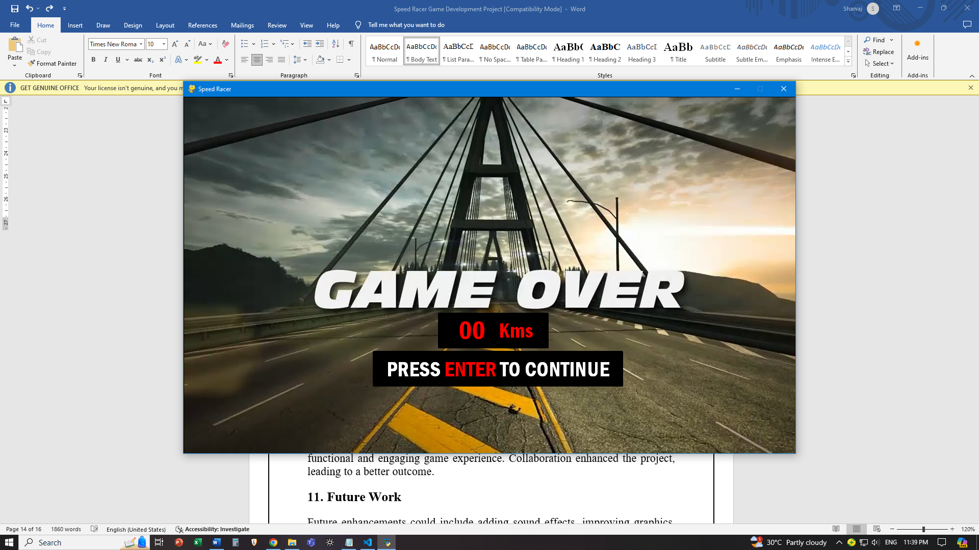

# Discussion

The discussion of the project typically involves an analysis of various aspects, including the game's design, development process, challenges encountered, lessons learned, and potential future enhancements.

# Conclusion

In conclusion, the Speed Racer project has been a rewarding journey in game development, combining learning, creativity, and technical skill. Through the creation of a 2D racing game using Python and Pygame, participants gained practical experience in programming, design, and problem-solving. The resulting game offers an engaging experience for players and serves as a testament to the dedication and talent of its creators. While the project marks a significant achievement, it also opens doors to future opportunities for expansion and enhancement

# Future Work

**Level Design:** Introduce multiple levels with increasing difficulty.

**Additional Features:** Add features such as power-ups, different car models, and more complex obstacle patterns.

**Multiplayer Mode**: Implement a multiplayer mode where players can race against each other.

# References

Pygame Documentation. (n.d.). Retrieved from <https://www.pygame.org/docs/> https://www.geeksforgeeks.org/car-race-game-in-pygame/

[https://www.youtube.com/watch?v=XON1IA8MxQw&list=PLz7mmheDeooW](https://www.youtube.com/watch?v=XON1IA8MxQw&list=PLz7mmheDeooW795HsNzkLS6TFQSa4Idtw) [795HsNzkLS6TFQSa4Idtw](https://www.youtube.com/watch?v=XON1IA8MxQw&list=PLz7mmheDeooW795HsNzkLS6TFQSa4Idtw)

# Decision Modeling in Game Design

Decision modeling in this game includes:

**Player Input:** Determine the keyboard controls for car movement and interaction with game elements.

**Obstacle Behavior**: Define the movement patterns and spawning logic for obstacles to create challenging gameplay.

**Fuel Mechanics:** Establish rules for fuel pickup appearance, depletion rate, and impact on gameplay dynamics.

**Scoring System:** Design a scoring mechanism based on distance traveled and fuel collected to incentivize player engagement.

**Game Over Conditions:** Specify conditions such as collision with obstacles or fuel depletion that trigger the end of the game.

**User Interface Design:** Plan the layout and elements of the user interface to convey essential information effectively.

**Art Style and Theme:** Decide on the visual style, theme, and aesthetics to create a cohesive and engaging game world.

**Audio Integration:** Determine the use of sound effects and background music to enhance immersion and feedback for player actions.

**Performance Optimization:** Identify areas for optimization to ensure smooth gameplay performance on various devices.

**Testing Strategy:** Establish testing procedures to evaluate game mechanics, balance, and overall player experience.